**EXPERIMENT NO. 2**

**AIM:** Practically implement and test the cross-wired cable and straight through cable using clamping tool and network lab cable tester.

**MATERIAL AND REQUIREMENTS**:

* Ethernet cables (bulk cable or pre-terminated cables)
* RJ-45 connectors
* Clamping tool (crimper)
* Cable tester (with two RJ-45 connectors)
* Wire stripper and cutter
* Marker and labels
* Safety goggles (for eye protection)

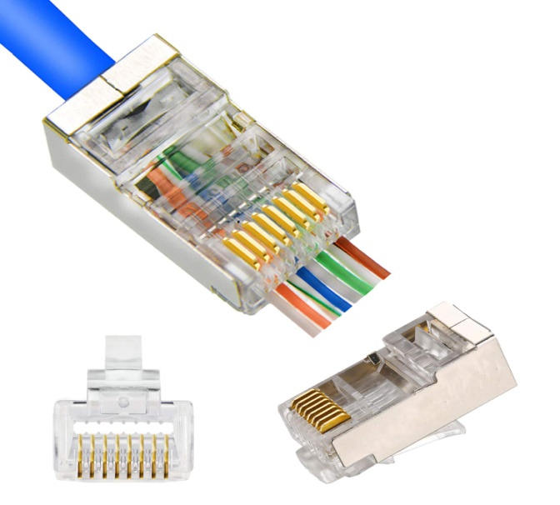

FIG: RJ-45 CONNECTOR

**INTRODUCTION**:

In computer networking, it's essential to understand the distinction between cross-wired (crossover) and straight-through cables. Cross-wired cables are used to connect similar devices (e.g., two computers), while straight-through cables are used to connect different devices (e.g., a computer to a switch). This practical will guide students through the process of creating and testing both cable types.

**PROCEDURE**:

**Part 1:** Cross-Wired (Crossover) Cable

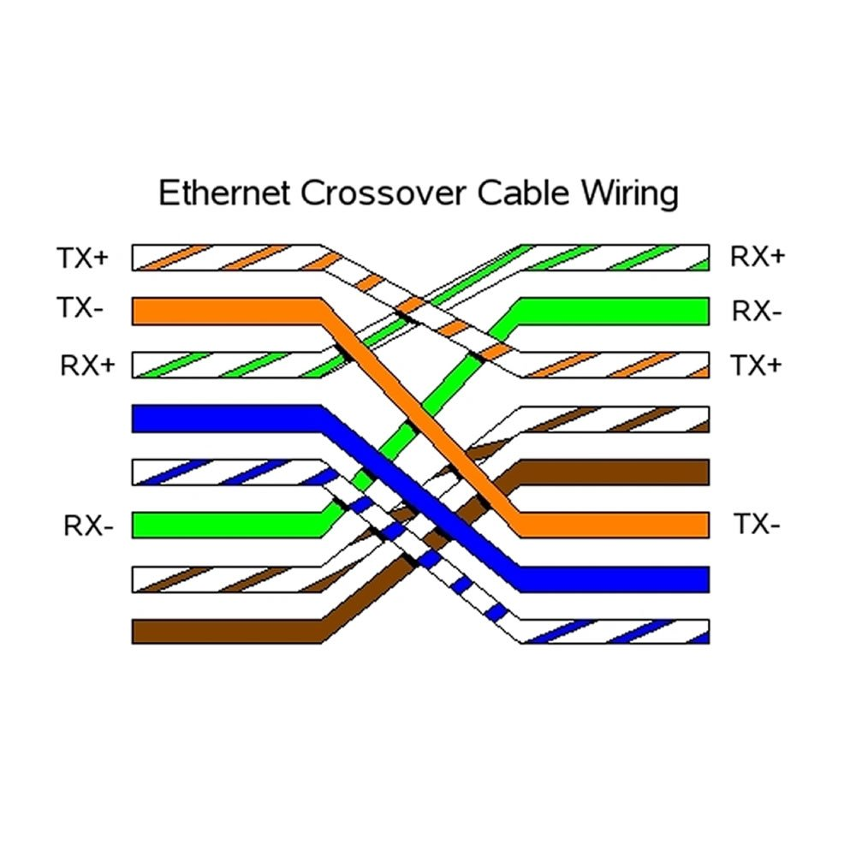

**Cable Preparation**:

* Start by cutting a length of Ethernet cable. Strip about 1 inch (2.5 cm) of the cable's outer insulation to expose the inner twisted pairs.

**Wire Arrangement**:

* Follow the T568A or T568B wiring standard for Ethernet cables.
* Cross-wire the transmit and receive wires at one end of the cable, as per the crossover cable standard (e.g., T568A at one end and T568B at the other).

**Connector Termination**:

* Insert the wires into an RJ-45 connector, ensuring proper alignment.
* Use a clamping tool to crimp the connector securely.
* Repeat the process for the other end, ensuring the same cross-wiring scheme.

**Part 2**: Straight-Through Cable

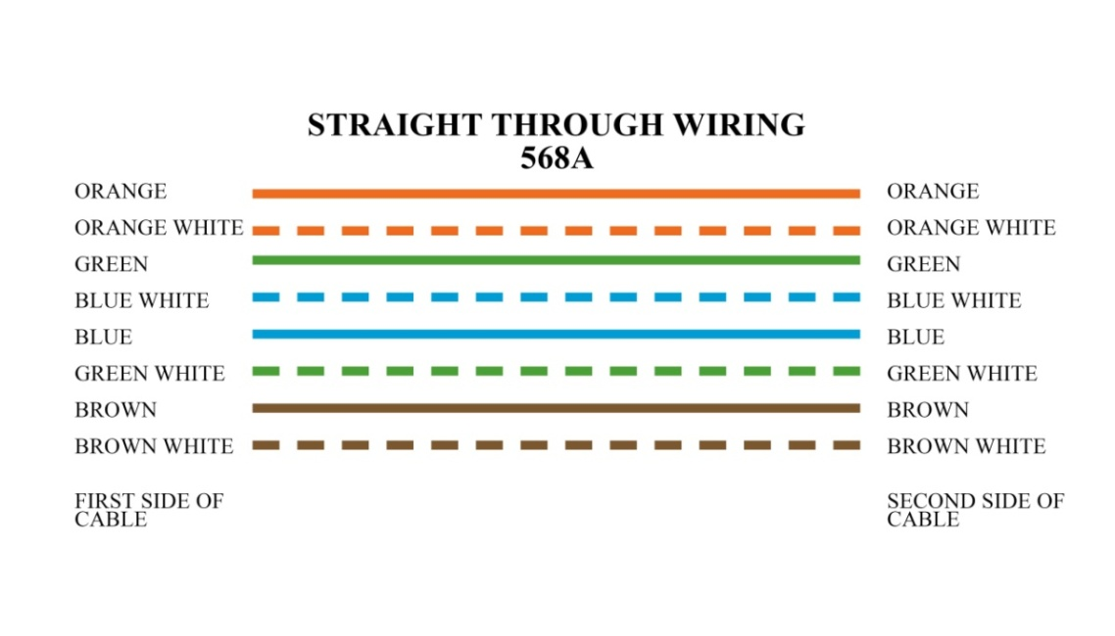

**Cable Preparation:**

* Cut another length of Ethernet cable. Strip about 1 inch (2.5 cm) of the cable's outer insulation to expose the inner twisted pairs.

**Wire Arrangement:**

* Follow either the T568A or T568B wiring standard for both ends of the cable.

**Connector Termination:**

* Insert the wires into an RJ-45 connector at one end, following the chosen standard.
* Use a clamping tool to crimp the connector securely.
* Repeat the process for the other end, ensuring the same wiring standard is used.

**Part 3:** Testing Cables

**Lab Cable Tester:**

* Plug one end of the created cross-wired cable into one RJ-45 connector of the lab cable tester.
* Plug the other end into the second RJ-45 connector of the tester.
* Check the tester's display for a successful connection.
* Repeat Testing for Straight-Through Cable:
* Test the straight-through cable in the same manner using the lab cable tester.
* Verify that it also shows a successful connection.